**ADDENDUM #1 – JULY 19, 2024**

RE: **Port of Bandon**

High Dock Building

**Project #22.01**

TO: Prospective Bidders

This Addendum forms a part of the Contract Documents and modifies the original Documents dated February/June 2024, as noted below. Acknowledge receipt of this Addendum in the space provided on the Bid Form. Failure to do so may subject Bidder to disqualification.

This Addendum consists of **FOUR (4)** page(s) together with the following attachments:

* **Section 00-7346 Prevailing Wage Rates**
* **Davis-Bacon Act Coos County Wage Rates**

## CHANGES TO PROJECT MANUAL:

1. **Section 00-4100 Quote Form, Paragraph 1.05:** ADD the following: “F. By signing this Proposal, the Subcontractor agrees to comply with the Buy America Provisions, described in Section 01-1000, for only Rooms Public Toilet #12, Shower #13, Public Toilet #15, & ADA Shower #16.”
2. **Section 00-7346 Prevailing Wage Rates:** ADD attached section in its entirety.
3. **Davis-Bacon Act Coos County Wage Rates:** ADD attached section in its entirety.
4. **Section 01-1000 Summary:** ADD the following: “1.06 Buy America Provision
   1. For Rooms Public Toilet #12, Shower #13, Public Toilet #15, & ADA Shower #16, only:
   2. As required by Section 70914 of the Infrastructure Investment and Jobs Act (Pub. L. 117-58), on or after May 14, 2022, none of the funds under a federal award that are part of a Federal financial assistance program for infrastructure may be obligated for a project unless all the iron, steel, manufactured products, and construction materials used in the project are produced in the United States, unless subject to an

22.01 Port of Bandon – High Dock Building

Page 1 ADDENDUM #1

July 19, 2024

approved waiver. Recipients must include the requirements in this section all subawards, including all contracts and purchase orders for work or products under this program.

* 1. None of the funds provided under this award may be used for a project for infrastructure unless:
     1. All iron and steel used in the project are produced in the United States This means all manufacturing processes, from the initial melting stage through the application of coatings, occurred in the United States,
     2. All manufactured products used in the project are produced in the United States. This means the manufactured product was manufactured in the United States, and the cost of the components of the manufactured product that are mined, produced, or manufactured in the United States is greater than 55 percent of the total cost of all components of the manufactured product, unless another standard for determining the minimum amount of domestic content of the manufactured product has been established under applicable law or regulation, and
     3. All construction materials are manufactured in the United States. This means that all manufacturing processes for the construction material occurred in the United States.
  2. This Buy America preference only applies to articles, materials, and supplies consumed in, incorporated into, or affixed to an infrastructure project. As such, it does not apply to tools, equipment, and supplies, such as temporary scaffolding, brought to the construction site and removed at or before the completion of the infrastructure project. Nor does a Buy America preference apply to equipment and furnishings, such as movable chairs, desks, and portable computer equipment, used at or within the finished infrastructure project but are not an integral part of the structure or permanently affixed to the infrastructure project.
  3. For more information, visit the Department's Buy America site at [www.doi.gov/grants/BuyAmerica](http://www.doi.gov/grants/BuyAmerica) and the Office of Management and Budget's site at [www.whitehouse.gov/omb/management/made-in-america/](http://www.whitehouse.gov/omb/management/made-in-america/).”

1. **Section 08-1113 Hollow Metal Doors and Frames, Paragraph 2.04, Item D:**

REPLACE “Provide knock-down type” with “Provide welded type.”

1. **Section 08-7100 Door Hardware, Paragraph 4.05:**
2. **Item A, HW-50:** REPLACE “Motorized Panic Device with vertical rods” with “Rim Panic Device,” and ADD “14. Power Supply.”
3. **Item B, HW-51:** DELETE “15. Request to Exit,” and “16. Power Transfer.”

22.01 Port of Bandon – High Dock Building

Page 2 ADDENDUM #1

July 19, 2024

1. **Item C, HW-52:** DELETE “5. Door Position Switch.”
2. **Section 22-0500 Plumbing Materials and Methods, Paragraph 2.06, Item C:** After, “or at least 2 layers of UPC 10 mil tape,” ADD, “For materials located outside and subject to marine environments, provide Type 304 or 316 Stainless Steel.”
3. **Section 22-1000 Plumbing Pipes and Pumps, Paragraph 2.01, Item C3:** After, “matching piping manufacturer,” ADD, “Stainless Steel press fittings for piping under dock and where exposed to outside.”
4. **Section 23-0500 HVAC Materials and Methods, Paragraph 2.01:** ADD “E. Corrosion Protection: Provide materials which are Type 304 or 316 S.S. or factory painted to prevent corrosion for all materials installed outside and subject to the marine environment.”

## CHANGES TO DRAWINGS:

1. **Sheet P1.0 Underslab Plumbing Plan:**
   1. ADD the following General Notes: “6. See Detail 2/P1.0 for pipe support detail below deck,” and, “7. All pipe support materials (threaded rods, clevis hangers, brackets, bolts and washers, etc.) exposed to the outside and below dock shall be Type 304 or 316 S.S.”
   2. ADD the below Detail 2/P1.0 Pipe Hanger.

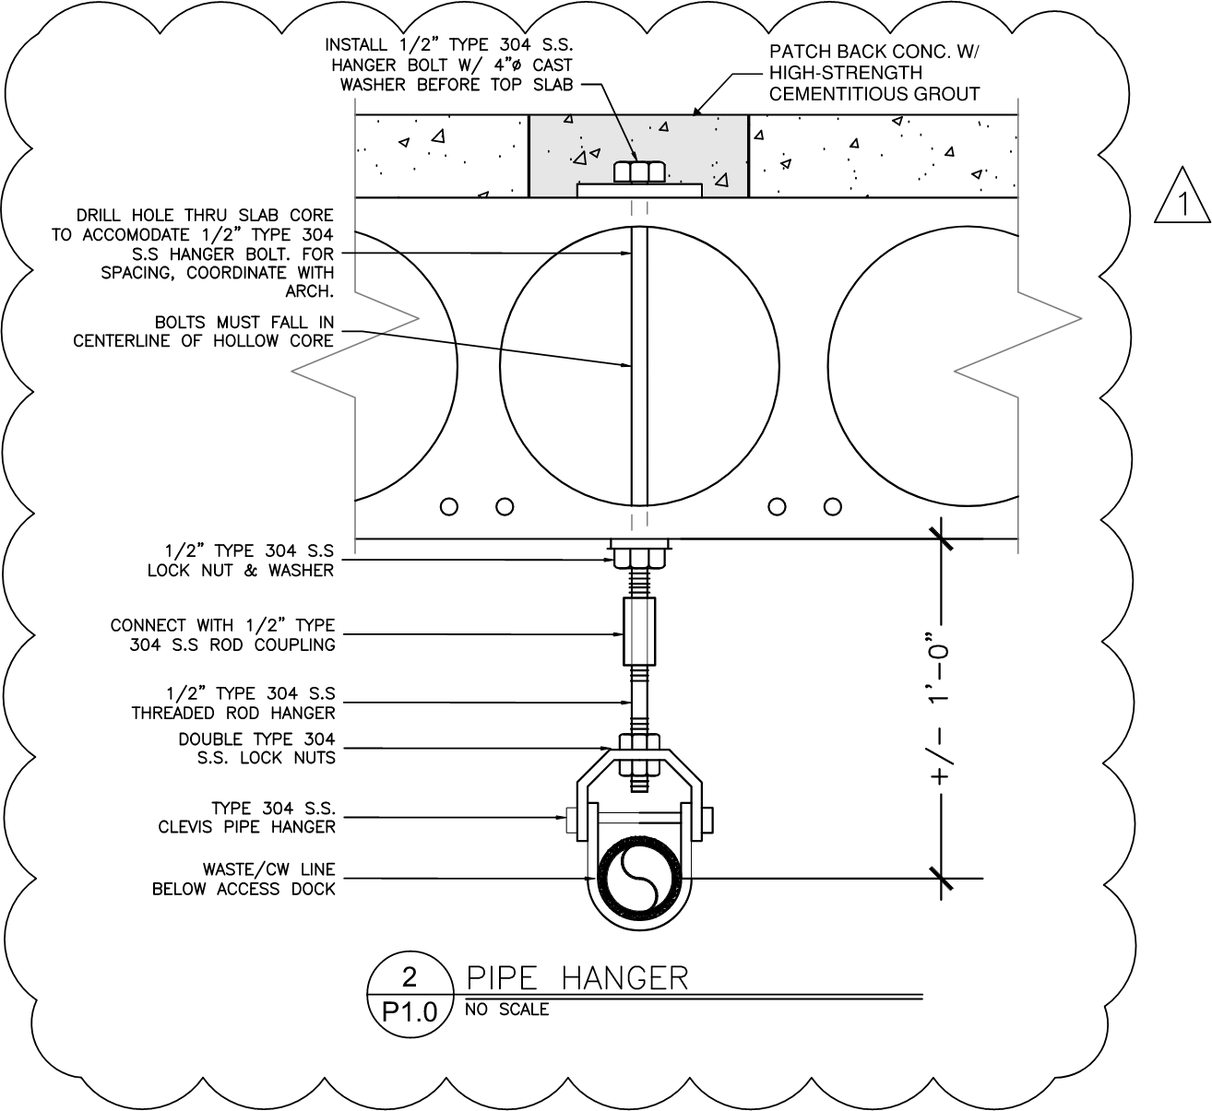

22.01 Port of Bandon – High Dock Building

Page 3 ADDENDUM #1

July 19, 2024

1. **Sheet P2.0 Plumbing Floor Plan:** In ADA Shower Room #16, REPLACE “SH-1” with “SH-2.”

## END OF ADDENDUM #1

* 1. Port of Bandon – High Dock Building

Page 4 ADDENDUM #1

July 19, 2024